**ASSIGNMENT 1.2**

PROBLEM STATEMENT:

Explain the below Linux commands with an example.

1. pwd:

Show the current working directory.

Output:



2. vi:

Edit the filename starting at line 1.

Output:





3. touch:

Create or update a file.

Output:





4. mkdir:

Create a directory dir.

Output:





5. rm:

Delete the file ‘word.txt’.

Output:



6. ls:

Directory list of files.

Output:

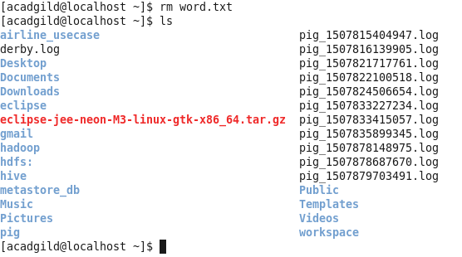

7. echo:

echo is a built-in command in the bash and C shells that writes its arguments to standard output.

Output:



8. cat:

Places the standard input into the file.

Output:

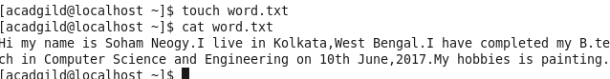

9. who:

who are you logged in.

Output:

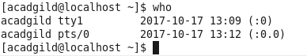

10. cd:

Change to home directory.

Output:



11. date:

Show the current date and time.

Output:



12. cal:

Show the month’s calendar.

Output:

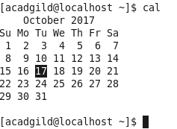

13. mv:

Move from file1 to file2.

Output:



14. cp:

Copy the contents of file1 to file2.

Output:





15. which:

Shows which application will run by default.

Output:

